**3. ReactJS-HOL**

1. Create the React App

|  |
| --- |
| npx create-react-app scorecalculatorapp |

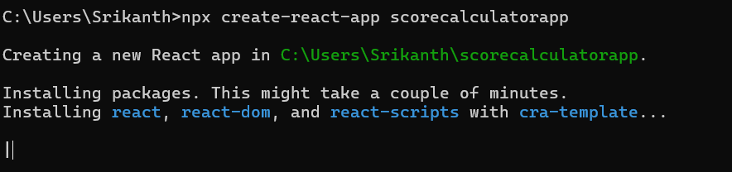

2. Create Components Folder

3. Create CalculateScore.js File under Components Folder

|  |
| --- |
| CalculateScore.js  import React from 'react';  import '../Stylesheets/mystyle.css';  const percentToDecimal = (decimal) => {    return decimal.toFixed(2) + '%';  };  const calcScore = (total, goal) => {    return percentToDecimal(total / goal);  };  function CalculateScore(props) {    return (      <div className="formatstyle">        <p className="Name"><strong>Name:</strong> {props.Name}</p>        <p className="School"><strong>School:</strong> {props.School}</p>        <p className="Total"><strong>Total Marks:</strong> {props.total}</p>        <p className="Score"><strong>Average Score:</strong> {calcScore(props.total, props.goal)}</p>      </div>    );  }  export default CalculateScore; |

4. Create Stylesheets Folder

5. Create mystyle.css File under Stylesheets Folder

|  |
| --- |
| Mystyle.css  .Name {    font-weight: 300;    color: blue;  }  .School {    color: crimson;  }  .Total {    color: darkmagenta;  }  .formatstyle {    text-align: center;    font-size: large;  }  .Score {    color: forestgreen;  } |

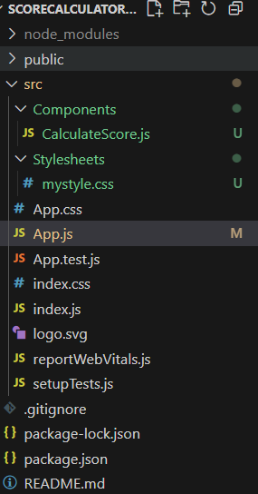

6.Modify App.js

|  |
| --- |
| App.js  import React from 'react';  import './App.css';  import CalculateScore from './Components/CalculateScore';  function App() {    return (      <div className="App">        <CalculateScore          Name="Rikitha"          School="Hyderabad Public School"          total={284}          goal={3}        />      </div>    );  }  export default App; |

7. Run App

|  |
| --- |
| npm start |

**Output:**

